**Leadership Spokane Alumni Newsletter- May 2021**

**Event Calendar**

**May 19th- May Book Club (6:00pm, Virtual)**

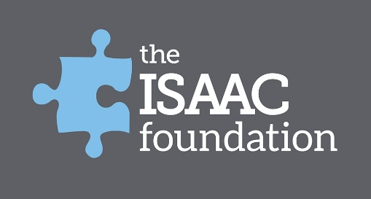

**Leadership Foolin’ and Schoolin’ (April 21st) Wrap-Up**

On April 21st we held the Leadership Spokane Alumni Foolin’ and Schoolin’ Spring Virtual Social. We had a lot of fun testing our skills, knowledge and artistic skills in Pictionary before getting the chance to hear from Holly Goodman of the Isaac Foundation talk about her story and the work their foundation does for friends and family touched by autism and other special needs through educational, emotional and financial support programs. Learn more about the Isaac Foundation at <https://theisaacfoundation.configio.com/page/home>.

Additionally, thank you to the Alumni who not only attended the event, but generously donated $650 to the organization that will help them continue their mission!

**Coming Soon…The 1983 Society!**

The unveiling of The 1983 Society is **less than a month away!** Stay tuned to the Leadership Spokane Alumni Facebook group page and next month’s newsletter for the revealing of The 1983 Society and discover how it will seek to further enhance and improve your Alumni experience, and make your involvement as meaningful as possible.

Do you have any suggestions for improving your alumni experience? We would love to hear them! Send any thoughts and ideas to [bdetienne@spokaneairports.net](mailto:bdetienne@spokaneairports.net).

**May Book Club (May 19th)**

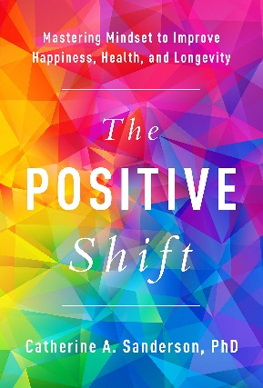

Our next virtual Book Club is happening on **Wednesday, May 19th at 6:00pm** and we will be examining the book *The Positive Shift: Mastering Mindset to Improve Happiness, Health and Longevity* by Catherine A. Sanderson. The book explores how a person’s mindset or thought patterns influences their psychological and physical health, and how it is possible to make minor adjustments to our mindset that will improve the quality and longevity of life.

Whether you’ve had a chance to read the book or not, this promises to be a stimulating conversation on how we can learn to live more positive and fulfilling lives. Plan to join us on May 19th! Zoom meeting information is below:

Join Zoom Meeting

<https://zoom.us/j/99479280956?pwd=Ym5ldWZybGVFd0dXWFFhR2RyeWk3dz09>

Meeting ID: 994 7928 0956

Passcode: 665903

**Leadership Spokane Alumni Facebook Group**

Want to stay up to date on the latest Leadership Spokane news and events? Join the Leadership Spokane Alumni Facebook Group. To access the page and become a member of the group visit: <https://www.facebook.com/groups/1913778138850572>.