Leadership Spokane Alumni Association January 2020 Newsletter
From all of us on the Alumni Association Board, Happy New Year!
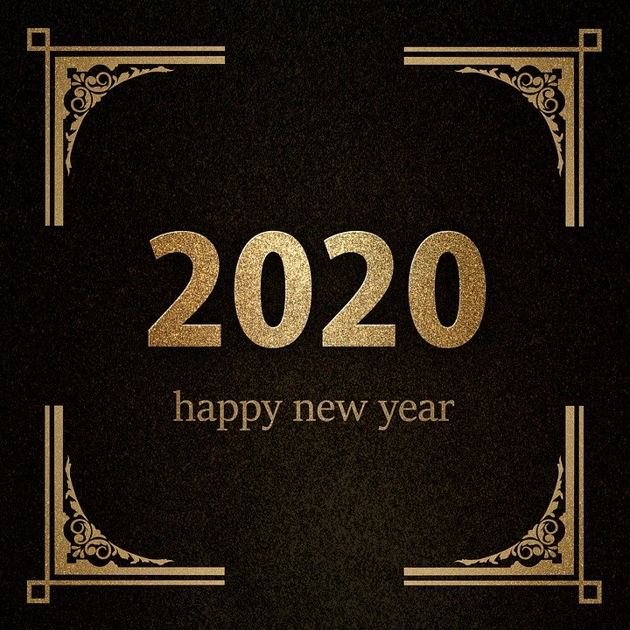

Upcoming Events Calendar
January 25th- 9th Annual Leadership Lights the Way Gala (6:00pm, Northern Quest Resort & Casino)
March 7th- Book Club (6:00pm, Forza Coffee at 29th and Regal)
March 14th- Spring Social at Spokane Chiefs game (7:30pm, Spokane Arena)
May 7th- Book Club (6:00pm, location TBA)
June 11th- Leadership Spokane Class of 2020 Commencement

Fall Alumni Social
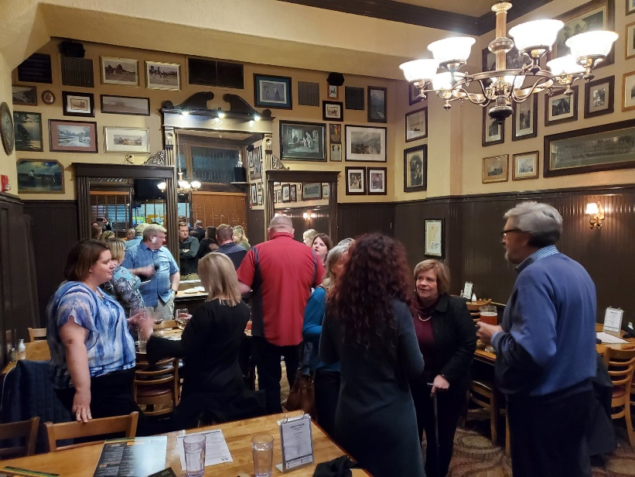 | 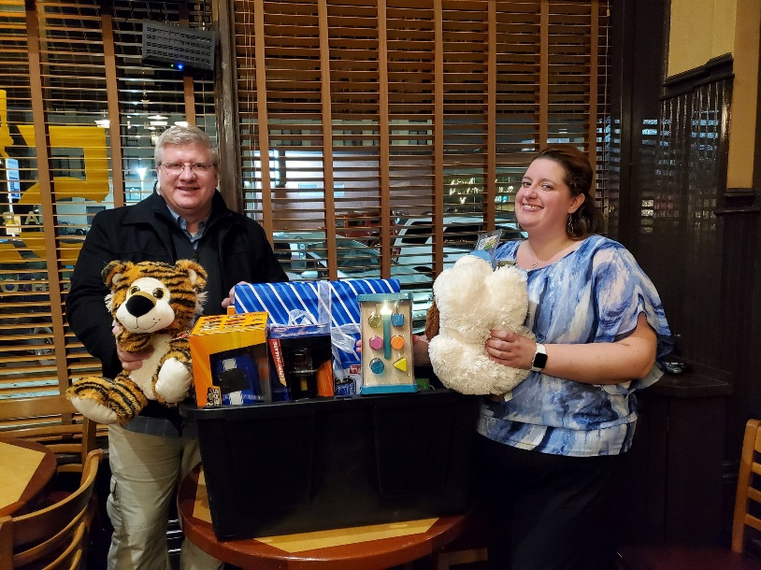

On November 12th the Leadership Spokane Alumni Association’s Fall Social took place The Onion’s downtown location. Representatives from several classes participated in the event. Not only did those in attendance enjoy great conversation with other alumni, they also brought several toys that were donated to Toys for Tots. Thank you to all of you who were able to attend!
Leadership Spokane Gala- Saturday, January 25th
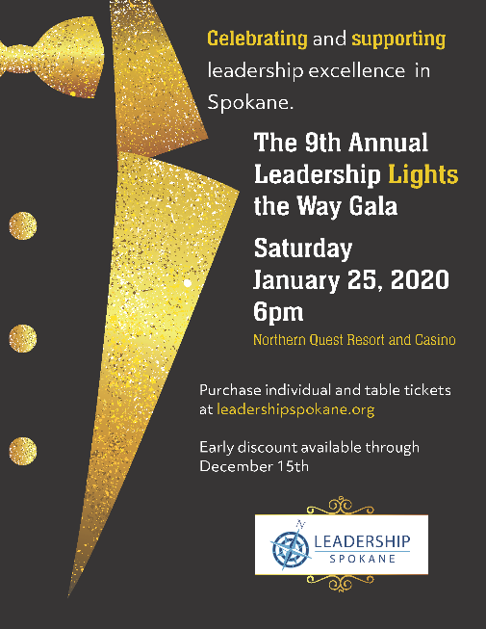
The 9th Annual Leadership Lights the Way Gala is just around the corner! Come join us on Saturday, January 25th at Northern Quest Hotel & Casino for a night of fun while supporting the development of leadership excellence in Spokane. The event, which features dinner, a silent and live auction, gift card pull and more, kicks off at 6:00pm. To purchase your tickets for the event go to https://leadershipspokane.ejoinme.org/MyEvents/Gala2020/tabid/1105652/Default.aspx.
If you are unable to attend the event, you can still participate by becoming an event sponsor or making a donation to the organization. Follow the ticket link above and scroll below the single ticket and table ticket listings to enter your contribution.
Alumni Book Club- Thursday, March 5th

An important part of every leader’s toolbox is continuously learning, and one way to gain new knowledge is through reading books from other leaders. Take advantage of the opportunity to do just that with the Alumni Association’s next Book Club gathering on Thursday, March 5th at 6:00pm at Forza Coffee (2829 E 29th Avenue).
We’ll be discussing Rana Foroohar’s book Don’t Be Evil: How Big Tech Betrayed Its Founding Principles- And All of Us. Foroohar examines how today’s largest tech companies hijack our data, livelihoods, social fabric and minds. Pick up a copy of Don’t Be Evil at the library or wherever you purchase your books, and after finishing the book come out to discuss it with others. We hope to see you on March 5th!
Spring Alumni Social- Saturday, March 14th
You’ve probably been to a Spokane Chiefs game, but have you had a chance to view the game from behind one of the goals? Now’s your chance! Join us for the Leadership Spokane Alumni Association Spring Social at the Chiefs game on Saturday, March 14th at 7:30pm.
We’ll be taking in the game from the Washington Lottery Crease party area on ground level, next to the boards. A bar area will be set up with drinks for purchase. Tickets are only $17 for adults and $11 for children, and all ages are welcome. To order your tickets go to http://bit.ly/LeadershipSpokane.
Community Service Spotlight
Are you involved in a community organization or event, or passionate about a cause here in Spokane? Let us know what kinds of groups and causes you are involved in. This could be an opportunity to feature your group or cause in an upcoming Leadership Spokane Alumni newsletter!
Leadership Spokane Storytelling Event
Stories inspire emotion and action. This event is to celebrate leaders in our community and the stories they tell that have inspired support and action for their good work.
We invite you to this social event to hear stories from some of the people that make our community great, to meet members of the Leadership Spokane family, and to become inspired.
Stay tuned to the Leadership Spokane Alumni’s Facebook page for updates on the date, time and location of this one-of-a-kind educational event led by leaders, for leaders.
Giving Back to Leadership Spokane
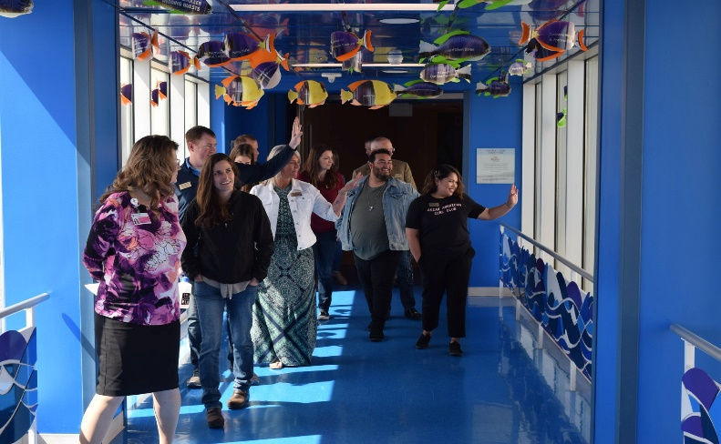 | 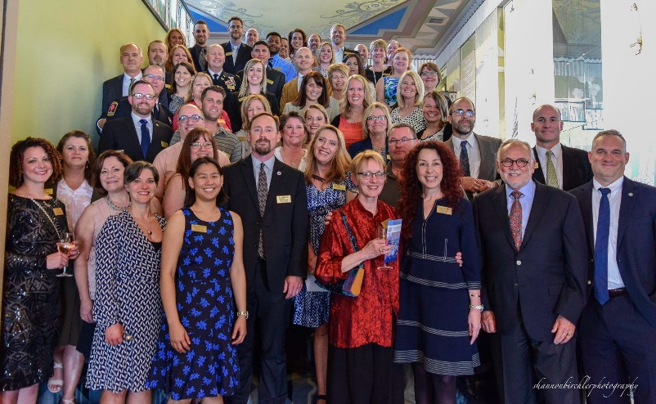

For nearly 40 years Leadership Spokane has cultivated leaders for Spokane. That tradition continues this year, and one reason for its continued success is the support of alumni who have become Legacy Society or Lifetime members. For only $50.00 a year you can become a Legacy Society member, or a one-time donation of $750.00 to become a Lifetime member.
Are you a member yet? Consider joining one of these groups. Your contribution towards a Legacy Society or Lifetime membership ensures that Leadership Spokane continues to develop leaders for many years to come.
To learn more and join at one of these membership levels visit https://leadershipspokane.org/what-we-do/alumni/legacy-society.html.

