Leadership Spokane Alumni Newsletter- June 2021

Event Calendar
June 10th – Leadership Spokane Class of 2021 Commencement
June 18th – Alumni Board Applications Due
June 24th – Alumni Tour of Riverfront Park (5:30pm, in-person)

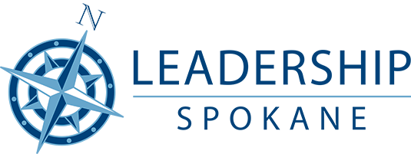

Congratulations Class of 2021!

The Leadership Spokane Alumni Board would like to congratulate the Class of 2021 on their upcoming graduation from the Leadership Spokane program later this week. We welcome you as the newest members of the Leadership Spokane Alumni!

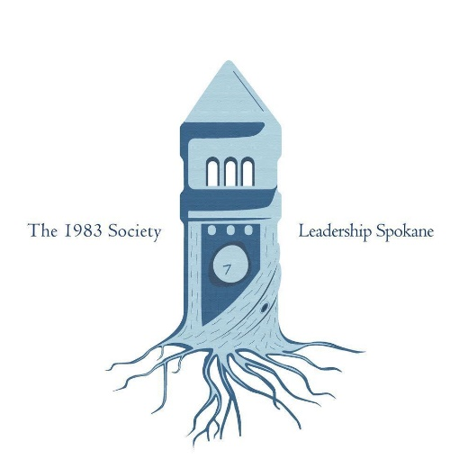

Introducing…The 1983 Society

Leadership Spokane Alumni, your Leadership Spokane experience doesn’t have to end at commencement. To help continue and enhance your experience further, and make your involvement as a Leadership Spokane alum as meaningful as possible, we are proud to announce the launch of The 1983 Society.

Formerly The Legacy Society, The 1983 Society’s mission is to build and foster a legacy of leadership in the Spokane area through GROWth opportunities that effectively strengthen our community. These opportunities include networking, educational and community service events throughout the year that are only offered to 1983 Society members.

There are several membership levels available:

Alum: $100, two-year membership ($50/year)
Affiliate: $225, five-year membership ($45/year)
Advocate: $400, ten-year membership ($40/year)
Ambassador: $750, lifetime membership

We encourage every Leadership Spokane alum to join. To learn which membership level is best for you and how to sign up visit The 1983 Society website at https://leadershipspokane.org/what-we-do/alumni/1983-society.html.

You won’t want to miss out on the exciting events we have planned for the coming year. Become a member of The 1983 Society, and make sure that your Leadership Spokane experience doesn’t end today.

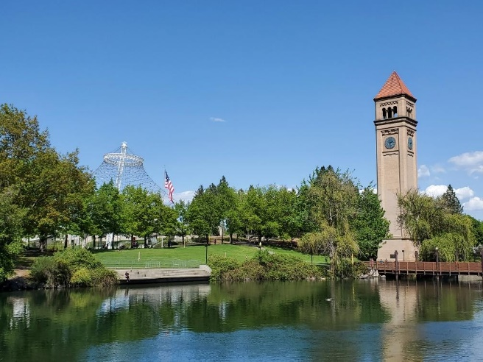
Alumni Tour of Riverfront Park- Thursday, June 24th

Remember how enjoyable it was to go on tours of area businesses and organizations during your time in Leadership Spokane? Well, now you have a chance to go on a tour once more. On Thursday, June 24th at 5:30pm Leadership Spokane Alumni have the chance to tour Riverfront Park to see the recent additions to the park and learn more about the newest things going on there. Following the tour, we’ll head over to David’s Pizza to enjoy good food and great company.

This event is open to all alumni. We’ll be meeting at the Rotary Fountain and starting the tour promptly at 5:30. We hope to see you there!

Leadership Spokane Alumni Board Opening

The Leadership Spokane Alumni Board has an additional opening for next year. If you’re looking to continue your Leadership Spokane experience, or trying to find ways to get more involved with Leadership Spokane alumni, this is a great opportunity for you! You’ll get the chance to interact with other program alumni and help plan, execute and attend alumni events throughout the program year.

To start the application process go to https://leadershipspokane.org/what-we-do/alumni/alumni-board-apply.html. Applications are being accepted through June 18th.

Leadership Spokane Alumni Facebook Group
Want to stay up to date on the latest Leadership Spokane news and events? Join the Leadership Spokane Alumni Facebook Group. To access the page and become a member of the group visit: https://www.facebook.com/groups/1913778138850572.

