Content for November Leadership Spokane Alumni Newsletter

Lifetime Alumni Achievement Award
Spokane residents are so lucky to be surrounded by talented Leadership Spokane alums who emulate servant leadership. Alums do this by the way they serve their community, their organizations, Leadership Spokane and others.

This is the highest award bestowed to Leadership Spokane alums! These recipients have achieved exceptional success in their professions, served as exemplary role models, demonstrated commitment and service to Leadership Spokane, and have bettered their community.

We invite you to nominate someone who you know who meet the criteria to receive the Lifetime Alumni Achievement Award. Don’t forget to submit nominations no later than November 15, 2019. The nominations will be reviewed by the Leadership Spokane Alumni Board and the award will be given to the recipient at the annual Leadership Spokane Gala in January! GO ahead, nominate someone now! Click on the following link:
https://leadershipspokane.org/awards/alumni-lifetime-achievement-award.html

This is not another ordinary book club!
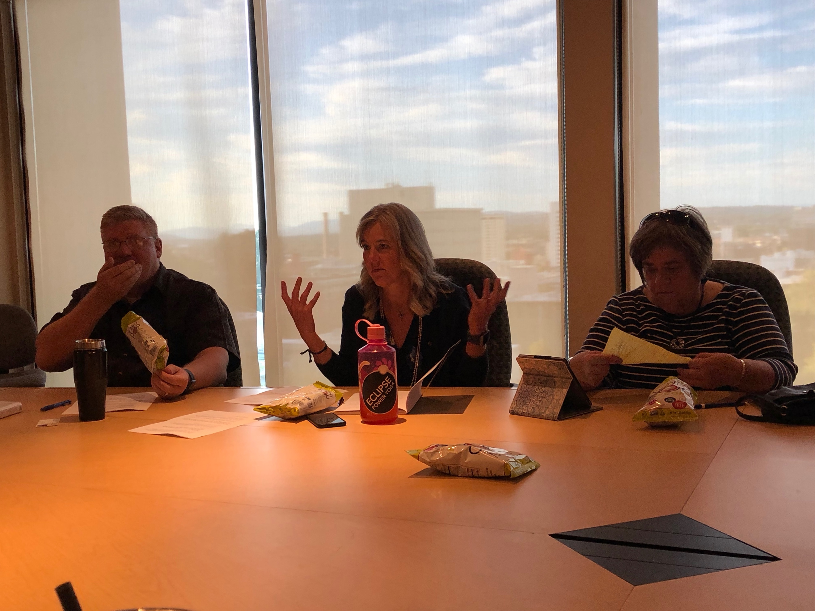
After conducting some valuable surveys and focus groups the LS Alumni Board received feedback about what Leadership Spokane alums want. We learned that they wanted to engage in continued learning and sometimes without the bar scene. We heard you say you wanted to connect with other alums with the same foundation of Servant Leadership. In September, Stephanie Huber Brady, Class of 2009, facilitated the book discussion revolving around the book 10% Happier by Dan Harris. We had a great attendance representing at least six different classes!
Bart Logue, Stephanie Brady, and Judith Kampf
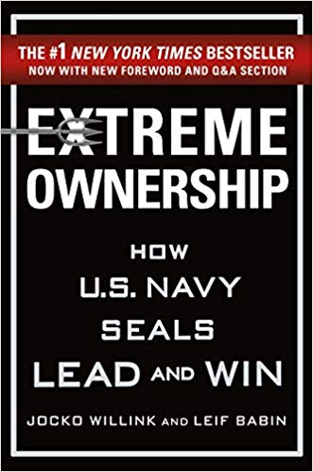
This month, we will explore Extreme Ownership written by Jocko Willink and Leif Babin, facilitated by Kent Wales, Class of 2009. These two book club meetings have been hosted by Karene Loman, Class of 2009 at Keller Williams. Join us on Thursday, November 7th at 6:00 p.m. at 799 S. Stevens, Spokane!

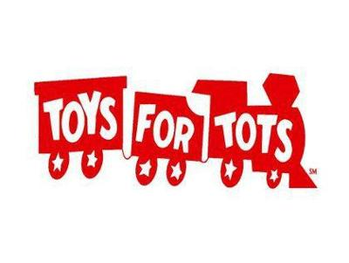
For those who like to connect over a glass of beer, wine or great food, we invite you to join us for a Fall Leadership Spokane Alumni Gathering on Tuesday, November 12th at The Onion downtown Spokane. We will be collecting new toys for Toys for Tots. We can’t wait to see whose class is best represented at this event. Check out the menu by following this link: http://theonion.biz.

Are you a member?
As members of the Leadership Spokane Alumni Board we often get questions about the difference between being an alum and being a part of the Legacy Society. This is a great question. If you’ve completed the Leadership Spokane curriculum, you are automatically a part of the Leadership Spokane alumni family. Those who believe in the mission of Leadership Spokane and want special opportunities to be involved with the organization take the opportunity to join the Legacy Society. We have over 45 Lifetime Legacy Society members and over 85 annual members. Annual members pay $50 to belong to the Legacy Society. Lifetime Legacy Society members have made a one-time $750 commitment to Leadership Spokane. Lifetime Legacy Society members are featured with biographies on the Leadership Spokane website. Check it out! https://leadershipspokane.org/what-we-do/alumni/lifetime-members.html?page=3.

Have you considered joining the Legacy Society? Now is the time! And it’s so easy! No writing a check and getting a stamp out, just click on the following link and decide how you want to remain engaged with Leadership Spokane. https://leadershipspokane.org/what-we-do/alumni/join-legacy-society.html

Featured in the News…
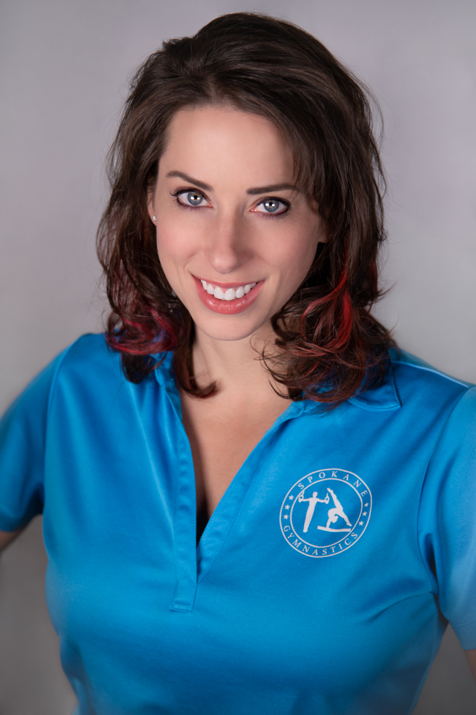
Speaking of Lifetime Legacy Society Members, have you met, Nadine Burgess, Class of 2018? This young woman is a local entrepreneur, a world-wide traveler, a constant improver, a believer in God, Dave Ramsey follower, and so much more. She empowers youth through her gymnastics business
https://www.facebook.com/SpokaneGymnastics10/ to never give up. She was selected as one of the Rising Stars by Journal of Business in 2016. She was in the first cohort of the Gonzaga University’s Women in Leadership Certificate Program and continues to give back to the community. Her most recent giveback was connecting with inspired entrepreneurs in Spokane at the Star-up Spokane program with Greater Spokane Incorporated. Nadine is most known for her handstands around the world. She is currently working a project that will have a positive impact in the community long beyond her time. She’s looking forward working with partners within the county, non-profits local educators and other organizations to make this project and legacy a reality.

Know someone who you would like to see featured in a future Leadership Spokane Alumni Newsletter, contact Monica Wales at monicakwales@gmail.com. Cheers!

Save the DATE!
The most anticipated annual Leadership Spokane Gala is being held on January 25, 2020 at Northern Quest Resort & Casino. Start getting your class or company tables together to ensure that there is a special place for you to enjoy the event! Stay tuned for more information about registration and amazing items that will be available during the silent auction.

