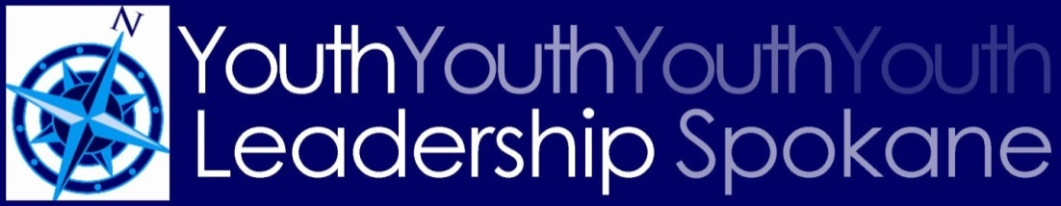

Schedule for 2017-2018 YLS
Locations TBA
Retreat Thursday, August 17 at Gonzaga University
Public Safety Monday, September 25
Human Needs Monday, October 30
Diversity Monday, November 27
Financial Education Monday, December 18
Arts Monday, January 22, 2018
Communication Monday, February 26, 2018
Governance Monday, March 26, 2018
Healthy Communities Monday, April 30, 2018
Stepping Up Monday, May 21, 2018
Commencement Thursday, June 7, 2018

Leadership Spokane, 801 W. Riverside Ave., Suite 220, Spokane WA 99201 | 509-321-3639 | www.leadershipspokane.org

